ITECH1400 - Fundamentals of Programming

Assignment # 2 - Biorhythms

Student Name: Melvin M. Flores

Student ID: 30352985

Lecturer: Kiran Chadha

Date Submitted: 24 June 2019

Table of Contents

1. INTRODUCTION 2

1.1 Basic - Biorhythms 2

*1.1.1* *Description of Biorhythms* 2

*1.1.2* *Description of Biorhythms as sine and cosine curves* 2

*1.1.3* *Pseudocode for the calculation of Biorhythms* 4

*1.1.4* *Graphical Display* 5

1.2 Graphical Display - Biorhythms 6

*1.2.1* *Annotation of the curves with day and date* 6

*1.2.2* *Demonstration that correct day/date annotation is implemented in code* 7

*1.2.3* *Demonstration of features that adds value* 8

*1.2.4* *Discussion* 11

2. CONCLUSION 12

3. References 13

List of Figures

Figure 1 Biorhythms Sine Formulas 3

Figure 2 Sample Biorhythm Cycles 3

Figure 3 Graphical display of Biorhythm cycles 5

Figure 4 Sample code for annotation 7

Figure 5 Sample output for annotation 7

Figure 6 My BiorhthymCycleGenerator Python program – Actual code 10

Figure 7 Graphical display of Biorhythm cycles with features that adds value 10

# INTRODUCTION

Biorhythm have been around since the 19th century and were very popular in the 1970s. Just as we have 4 seasons in one year which are Spring, Summer, Autumn and Winter, similarly our body also has 3 cycles since our birth which are Physical, Emotional and Intellectual. Awareness of these 3 cycles will help us navigate and realize our highest potential in our daily lives.

## Basic - Biorhythms

### Description of Biorhythms

Biorhythm, in my own words, comes from two root words, bio and rhythm, which means life and cycle, so simply put it is the lifecycle which started from our birth and will span until the end of our lifetime. These lifecycles are our Physical cycle, Emotional cycle and Intellectual cycle.

Biorhythm, according to Wikipedia (2019), comes from the Greek word bios which means "life" and rhuthmos which is "any regular recurring motion, rhythm". It is an attempt to predict various aspects of a person's life through simple mathematical cycles. The theory was developed by Wilhelm Fleiss in the late 19th century and was popularized in the United States in late 1970s. Most scientists believe that the idea has no more predictive power than chance. The theory of biorhythms is a theory that claims our daily lives are significantly affected by rhythmic cycles.

Morollo, M (2019), suggests that Biorhythms are body cycles that regulate our health, emotions and intellect. We have three basic biorhythm cycles: a 23-day physical cycle, a 28-day emotional cycle, and a 33-day intellectual cycle.

Physical cycle regulates physical strength, stamina, metabolic rate, initiative and hand and eye coordination. And the emotional cycle regulates moods, nerves, affection and creativity. Then the intellectual cycle regulates logic, reasoning, concentration, alertness, sense of direction, power of deduction, memory and decision making.

It is possible that one or more cycles are in the positive amplitude of the Biorhythm and getting the composite value of the three cycles will give you an idea if you are having a good day or a not-so-good day. Simply, when the composite value is up, life feels good. Otherwise, life feels bad.

### Description of Biorhythms as sine and cosine curves

Biorhythm calculation are based on sine waves, see **figure 1**, which are oscillating waves. For the three formulas, the physical cycle, the emotional cycle and the intellectual cycle, you will notice that the only difference between the three is the number of days in the cycle: 23, 28 and 33.

For all the three formulas, *t* represents how many days you have been alive.

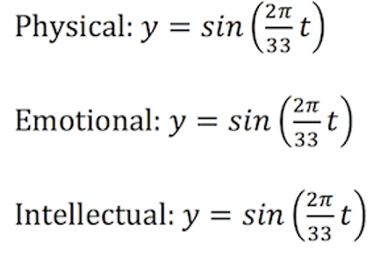`

Figure 1 Biorhythms Sine Formulas

With regards to the cosine waves, most Biorhythm calculators which are available online uses this wave instead of sine wave.

In **figure 2**, sample Biorhythm cycles were shown. When a cycle is high, it means it is easy to do well in that area. For example, if our intellectual cycle is high, amplitude is high, we will do better in examinations. But if we are in the low part of a cycle, amplitude is low, it is difficult to do well, we may have more arguments if our emotional cycle is low.

Biorhythms have critical points when individual cycles are switching from high periods to low and vice-versa. These are called the peak, the highest point in the cycle, wherein our cycles are heightened. And the through, the lowest point in the cycle, wherein our cycles are lessened. When the critical period is shifting up, life is on an upswing having awesome feelings or doing maximum performance. When going lower the effect feels like life is in a downswing, having an exhausted, frustrated or empty feeling.

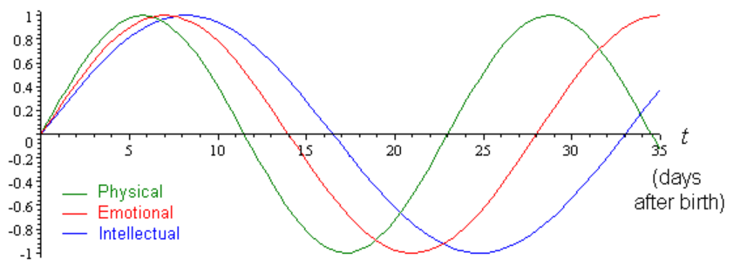

Figure 2 Sample Biorhythm Cycles

### Pseudocode for the calculation of Biorhythms

The pseudo-code I used in calculation of the Biorhythms were:

* Import mathematical, graphical and date libraries
* Ask user to input birthday and target date.
* Get current date to calculate number of days alive
* Transform the dates to its ordinal value
* Apply spread day of 17 to capture the whole cycle of all 3 cycles
* Create an array of dates for my x-axis
* Calculate the sine wave cycles for my y-axis
* Plot the biorhythm cycle using the x and y axis
* Add legends, x and y labels and title.
* Save the generated cycle as a pdf file.

### Graphical Display

I asked the user to input a birthday. In this example, the user inputs 01/03/1975. I also asked for a target date, in the example the user inputs 23/06/2019. My BiorhthymCycleGenerator Python program created the Biorhythm cycles, see **figure 3**. I varied the thickness of each cycle, with the Physical cycle the thinnest, Emotional cycle with average thickness, and the Intellectual cycle as the thickest. And I also indicated different colors for the three cycles. Red for Physical cycle, Blue for Emotional cycle and Green for Intellectual cycle. The legend was displayed. The x and y labels were also displayed, phase for the x-axis and amplitude for the y-axis. The title was also displayed, “Biorhythm cycles”. Along with the user’s inputs which are the birthday and the target date, together with the calculated number of days alive.

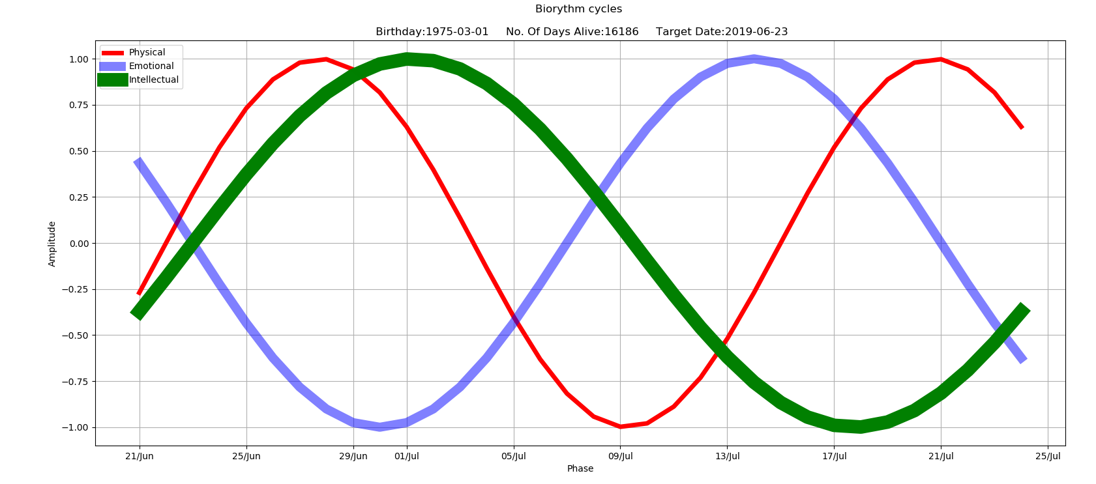

Figure 3 Graphical display of Biorhythm cycles

## Graphical Display - Biorhythms

### Annotation of the curves with day and date

Reading and understanding the lecture slides, as well as researching on the internet, I have found and applied ways to made annotation.

First is using the text () function. The text () function is used to add text in a specified location pointed by the x-axis and y-axis. See below for sample code fragment syntax:

*text(x-axis, y-axis, 'write text here')*

Another is the use of the annotate () method, which is used to annotate some feature of the plot. It uses 2 arguments. The first argument pointed by the x-axis and y-axis is the location being annotated. The second argument pointed by another x-axis and y-axis is the location of the text for the annotation. See sample code fragment syntax below:

*annotate('write text here', xy=(x-axis, y-axis), xytext=(x-axis, y-axis),*

*arrowprops=dict(facecolor='black', shrink=0.05),*

### Demonstration that correct day/date annotation is implemented in code

There were challenges to implement the correct day/date annotation in my code. It is because my x-axis were plotted as ordinal dates. I have tried many times, using different approaches and different syntax, but ultimately was frustrated in implementing the annotation in my code. As taught by the Matplotlib Development Team (2019), I learned by its tutorial in the internet, and the closest I can do is to just demonstrate a sample code and its sample output. See **figure 4** for sample code for annotation, and **figure 5** for sample output of annotation.

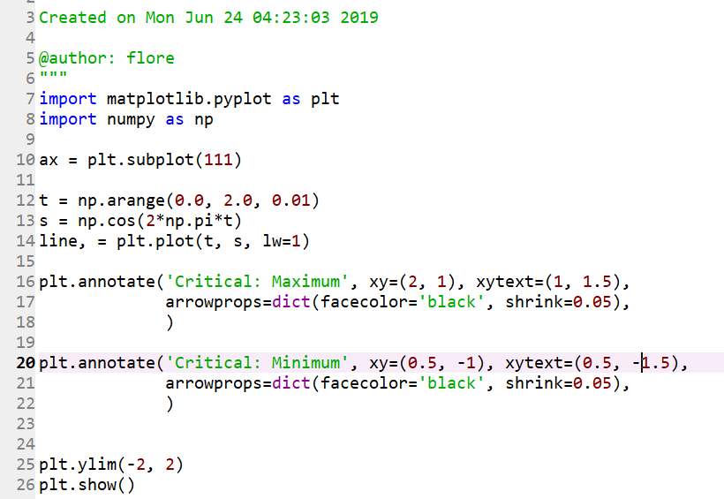

Figure 4 Sample code for annotation

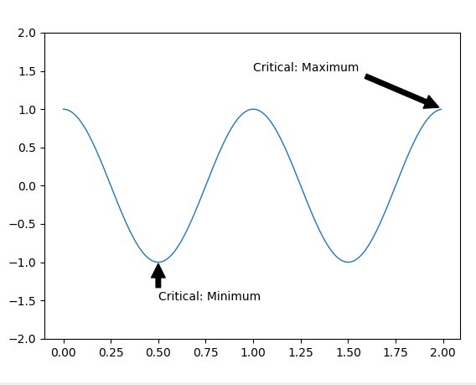

Figure 5 Sample output for annotation

### Demonstration of features that adds value

My BiorhthymCycleGenerator Python program, see **figure 6** for actual code, runs and it works. It created the Biorhythm cycles, see **figure 7**, which have features that adds value. My first feature is the thickness of each cycle, I varied each of them so that I can easily differentiate which cycle is which. I made the Physical cycle the **thinnest**, Emotional cycle with **average thickness**, and the Intellectual cycle as the **thickest**.

Second feature is the colors of each cycle, I differentiated each of them so that I can easily see which cycle it refers to. I chose three different colors for the three cycles, **Red** for Physical cycle, **Blue** for Emotional cycle and **Green** for Intellectual cycle.

Thirdly, legend is the next feature. I created the legend to identify which sine waves belong to a biorhythm cycle. The legend shows that the sine wave for Physical cycle is **Red**, the sine wave for Emotional cycle is **Blue** and the sine wave for Intellectual cycle is **Green**.

My fourth feature were the x-axis and y-axis labels. The x and y labels were displayed, it shows **Phase** for the x-axis and **Amplitude** for the y-axis.

Grid was also one of the features. It shows the grid-lines of the graph.

Another feature was the title. The title was also displayed, “**Biorhythm cycles**”. Along with the user’s inputs which are the **Birthday** and the **Target date.** Thecalculated **number of days alive** was also displayed.

My last feature was the pdf file that it created which shows the Biorhythm cycle. It was named **Biorythm.pdf**

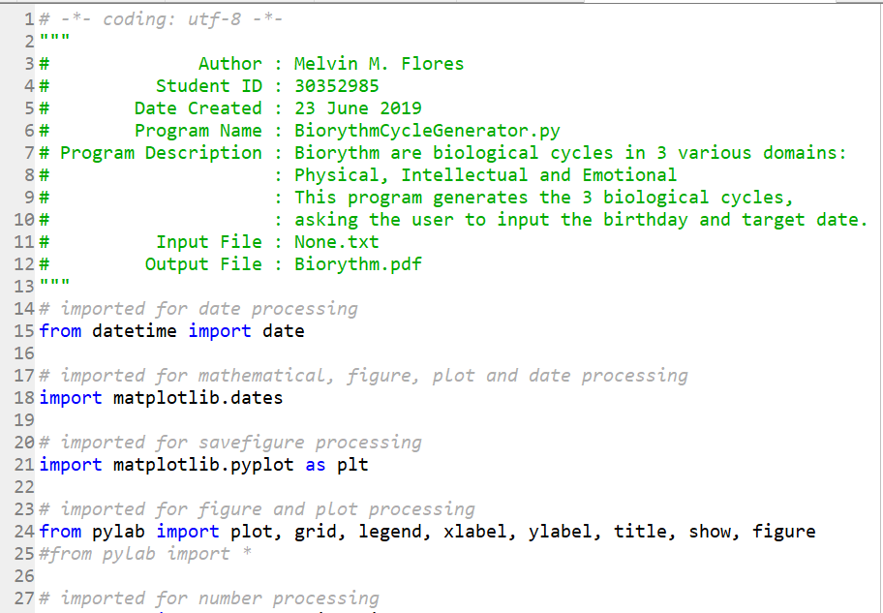

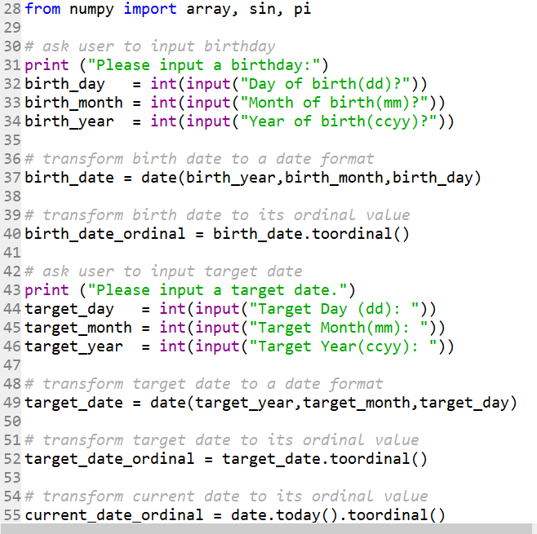

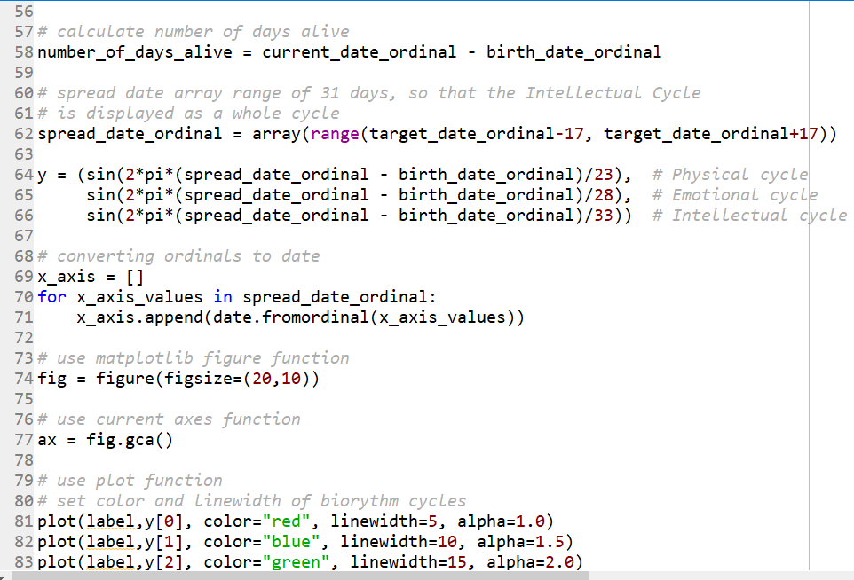

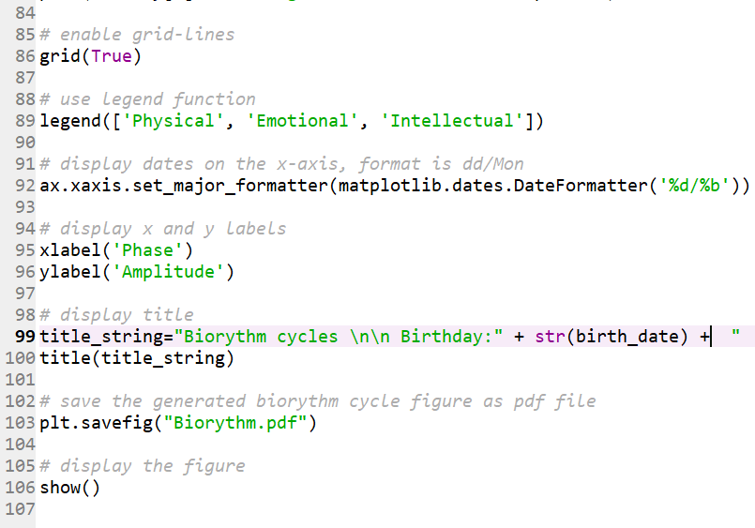

Figure 6 My BiorhthymCycleGenerator Python program – Actual code



Figure 7 Graphical display of Biorhythm cycles with features that adds value

### Discussion

My BiorhthymCycleGenerator Python program was created so that the different life cycles can be displayed. These life cycles are the Physical cycle, Emotional cycle and Intellectual cycle.

I first imported the mathematical, graphical and date libraries. The libraries I imported were ‘datetime’, ‘Matplotlib’, ‘Pylab’ and NumPy. These libraries are needed so that we can use its existing functions, which are date, mathematical, and graphical in nature.

Next, I ask user the user to input the birthday and the target date. I then formatted it to a date format, as well as to its ordinal format. I used the date ( ) and the toordinal( ) function. I also got the current date using the today( ) function, and I calculated the number of days alive.

I then applied a spread day of 17 before and after the target date to capture the whole cycle of all 3 cycles, as Intellectual cycle is the longest at 33-days.

For my x-axis, I created an array of dates for my x-axis based on the spread date. As for my y-axis, I calculated the sine wave cycles for the three different cycles.

I then plotted the biorhythm cycle using the x-axis and y-axis. I enabled the grid-lines, then added the legends. I also added the x-labels and y-labels. Title was also added. Finally, I saved the generated cycle as a pdf file.

# CONCLUSION

This is my first time to code a Python program using graphical libraries and plotting data. Given the lecture slides, lecture sample scripts, online resources such as the Glowing Python(2019), along with the discussion among fellow classmates, I was able to successfully create my own BiorhthymCycleGenerator Python program.

Knowing one’s Biorhythm cycle will raise awareness to oneself. Given the information shown by the Biorhythm, one can use it to his advantage. He can use it as a guide to know when it is best to perform a physical task, emotional task or intellectual task. It is also useful to know why a person is feeling either low or high physically, emotionally or intellectually, and it is because his biorhythm cycle is either low or high.

During the development of my BiorhthymCycleGenerator Python program, I applied in my codes the lessons in the lecture and laboratory class and the lessons in the online resources. Therefore, I can display the three different Biorhythm cycles: the Physical cycle, Emotional cycle and Intellectual cycle by using my BiorhthymCycleGenerator Python program.

# References

* Wikimedia Foundation, Inc. (2019, June 1). *Biorhythm.* Retrieved from

[*https://en.wikipedia.org/wiki/Biorhythm*](https://en.wikipedia.org/wiki/Biorhythm)

* Morollo, M. (2019). *How To Read a Biorhythm.* Retrieved from <https://www.techwalla.com/articles/how-to-read-a-biorhythm>
* Matplotlib Development Team ((2019, May 18)). *Pyplot tutorial.* Retrieved from <https://matplotlib.org/3.1.0/tutorials/introductory/pyplot.html>
* Glowing Python (2011, July 4). *How to plot biorhythm.* Retrieved from

https://glowingpython.blogspot.com/2011/07/how-to-plot-biorhythm.html